Name : Lokare Mahir Abdul Majeed

Roll no : 23AI34
Batch:02

EXPERIMENT NO- 10
AIM:
To study and implement the McCulloch-Pitts Model of artificial neuron for performing basic logical operations.
RESOURCE REQUIRED:
Google repository, Dataset, Jupyter Notebook
THEORY:
Backpropagation, short for Backward Propagation of Errors, is a key algorithm used to train neural networks by minimizing the difference between predicted and actual outputs. It works by propagating errors backward through the network, using the chain rule of calculus to compute gradients and then iteratively updating the weights and biases. Combined with optimization techniques like gradient descent, backpropagation enables the model to reduce loss across epochs and effectively learn complex patterns from data.
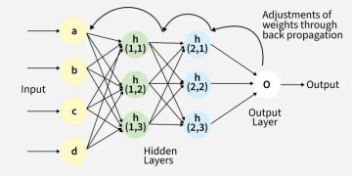
Back Propagation plays a critical role in how neural networks improve over time. Here's why:
1. Efficient Weight Update: It computes the gradient of the loss function with respect to each weight using the chain rule making it possible to update weights efficiently. 2. Scalability: The Back Propagation algorithm scales well to networks with multiple layers and complex architectures making deep learning feasible.
3. Automated Learning: With Back Propagation the learning process becomes automated and the model can adjust itself to optimize its performance.
Working of Back Propagation Algorithm
The Back Propagation algorithm involves two main steps: the Forward Pass and the Backward Pass.
1. Forward Pass Work
In forward pass the input data is fed into the input layer. These inputs combined with their respective weights are passed to hidden layers. For example in a network with two hidden layers (h1 and h2) the output from h1 serves as the input to h2. Before applying an activation function, a bias is added to the weighted inputs.
Each hidden layer computes the weighted sum (`a`) of the inputs then applies an activation function like ReLU (Rectified Linear Unit) to obtain the output (`o`). The output is passed to the next layer where an activation function such as softmax converts the weighted outputs into probabilities for classification.
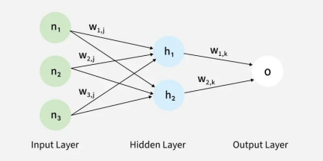
2. Backward Pass
In the backward pass the error (the difference between the predicted and actual output) is propagated back through the network to adjust the weights and biases. One common method for error calculation is the Mean Squared Error (MSE) given by:
MSE=(Predicted Output−Actual Output)2MSE=(Predicted Output−Actual Output)2 Once the error is calculated the network adjusts weights using gradients which are computed with the chain rule. These gradients indicate how much each weight and bias should be adjusted to minimize the error in the next iteration. The backward pass continues layer by layer ensuring that the network learns and improves its performance. The activation function through its derivative plays a crucial role in computing these gradients during Back Propagation.
Advantages
The key benefits of using the Back Propagation algorithm are:
∙ Ease of Implementation: Back Propagation is beginner-friendly requiring no prior neural network knowledge and simplifies programming by adjusting weights with error derivatives.
∙ Simplicity and Flexibility: Its straightforward design suits a range of tasks from basic feedforward to complex convolutional or recurrent networks.
∙ Efficiency: Back Propagation accelerates learning by directly updating weights based on error especially in deep networks.
∙ Generalization: It helps models generalize well to new data improving prediction accuracy on unseen examples.
∙ Scalability: The algorithm scales efficiently with larger datasets and more complex networks making it ideal for large-scale tasks.
Challenges
While Back Propagation is useful it does face some challenges:
∙ Vanishing Gradient Problem: In deep networks the gradients can become very small during Back Propagation making it difficult for the network to learn. This is common when using activation functions like sigmoid or tanh.
∙ Exploding Gradients: The gradients can also become excessively large causing the network to diverge during training.
∙ Overfitting: If the network is too complex it might memorize the training data instead of learning general patterns.

IMPLEMENTATION-
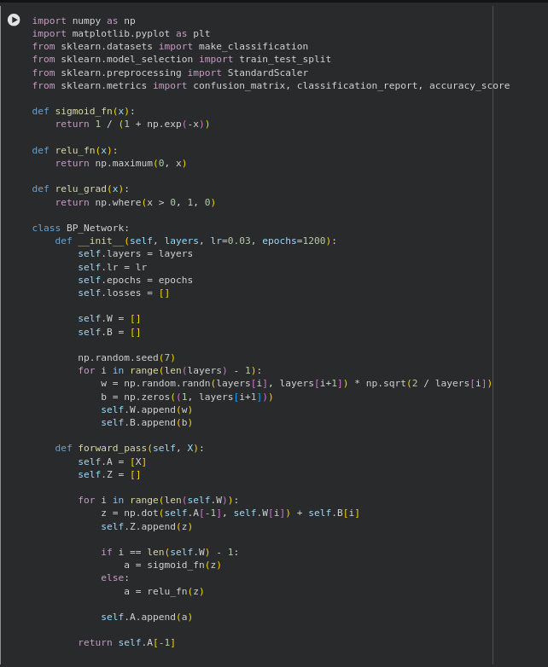
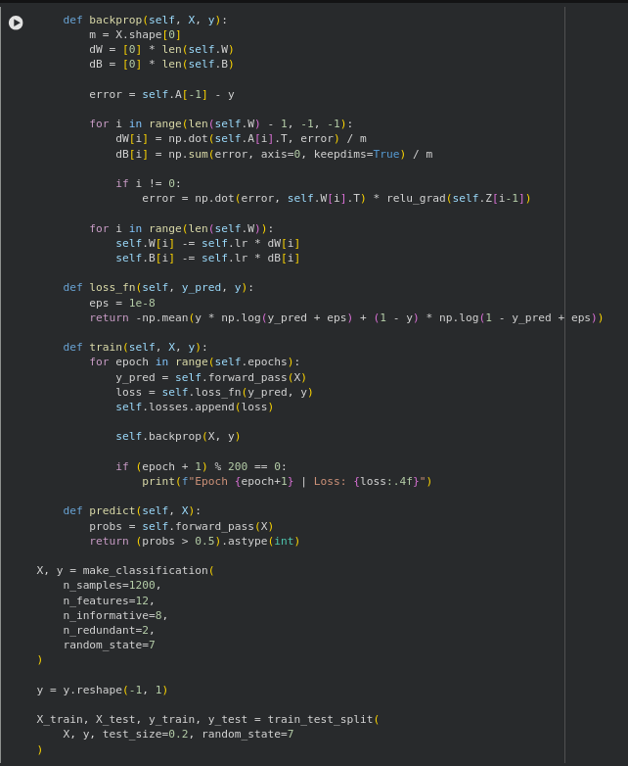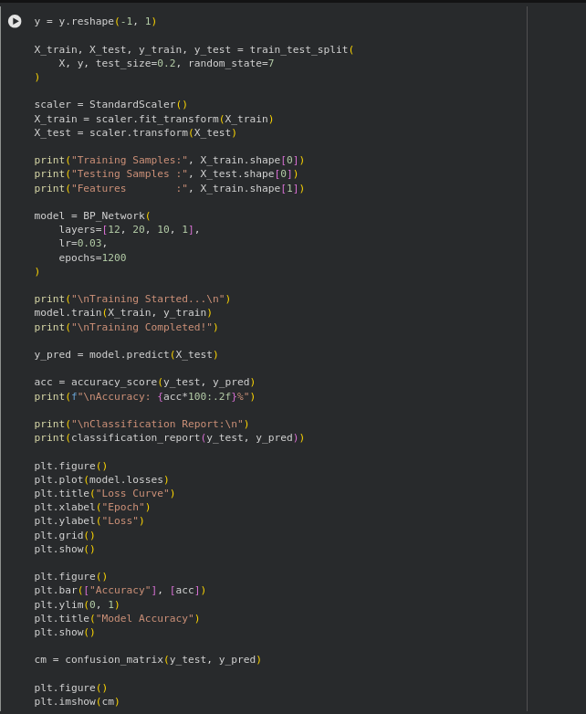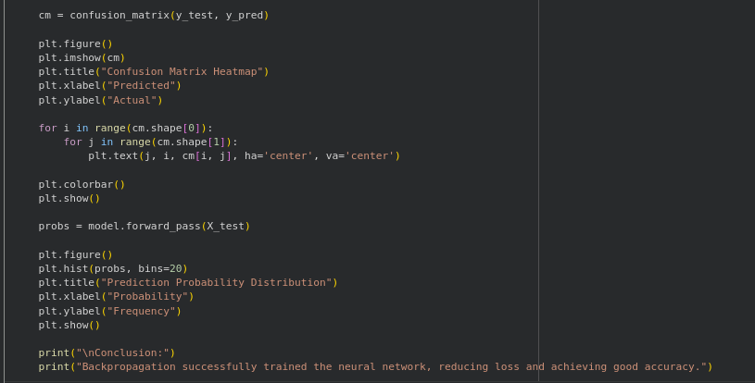

OUTPUT-
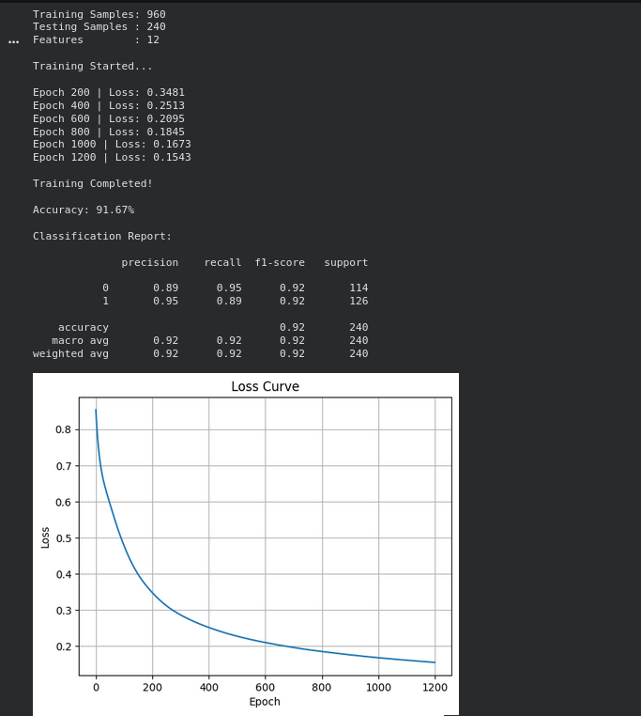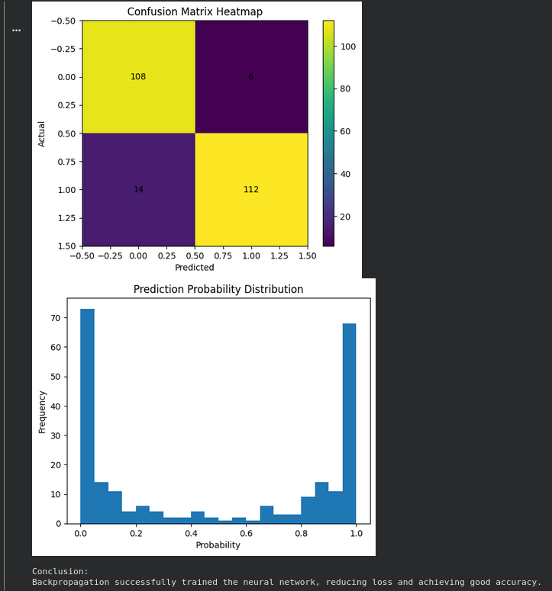
CONCLUSION –
Hence we have studied and implemented Back Propagation algorithm neuron model.

